**EXP NO 1: CREATE A SIMPLE CLOUD SOFTWARE APPLICATION AND PROVIDE IT AS A SERVICE USING ANY CLOUD SERVICE PROVIDER TO DEMONSTRATE**

SOFTWARE AS A SERVICE (SAAS).

**DATE: 25-09-2025**

**AIM:**

To create a simple cloud software application and provide it as a service using

any cloud service provider to demonstrate software as a service (saas).

**PROCEDURE:**

STEP1: GOTO ZOHO.COM

STEP 2: LOGIN TO THE ZOHO.COM

STEP 3: SELECT ONE APPLICATION

STEP 4: ENTER APPLICATION NAME

STEP 5: CREATED NEW APPLICATION

STEP 6: SELECT ONE FORM

STEP 7: THE SOFTWARE HASE BEEN CREATED.  
  
**OUTPUT :  
  
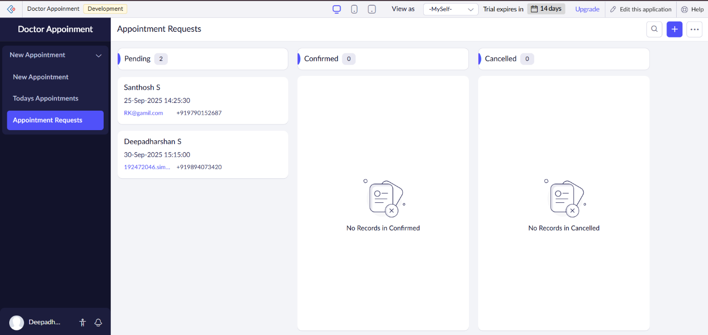**

**RESULT :**A simple cloud-based software application was successfully created in Zoho Creator. The application allowed storing and displaying data through forms and reports and was provided as a service by publishing and sharing it over the cloud. The app could be accessed through a web URL and integrated via Zoho Creator’s built-in REST APIs, thereby demonstrating the concept of delivering software as a service (SaaS).